SoftConsole RISCV Guide v1.0
Guide

16th February 2017
Rev 1.0
Revision History
Revision | Date | Description
1.0 | 16th February 2017 | Initial Draft

Table of Contents
1 Introduction 4
1.1 Abbreviation and Acronym 4
1.2 Reference Documents 4
2 Design Requirements 5
3 Demo Design 5
3.1 Ubuntu 14.04 5
4 Board Setup 6
5 Debugging Programs 6

Introduction
This document is written to demonstrate how to use SoftConsole with RISCV. It will show a user the steps involved in downloading, importing and debugging designs for the RISCV. For this guide the M2S090 Security Evaluation Kit and SoftConsole projects found on the Github page linked below. If this this is your first time using the RISCV with SoftConsole, it is recommended that you first read the “FlashPro Express Guide V1.0”.

Abbreviation and Acronym
Following table contains basic acronyms which will be used in all documents related to the SoftConsole RISCV guide.

Acronym | Details

Reference Documents
This section contains the reference documents mentioned in the document.
Document ID | Document Name | Document Location
[R0] | Microsemi SmartFusion2 Security Development Kit | https://www.microsemi.com/products/fpga-soc/design-resources/dev-kits/smartfusion2/sf2-evaluation-kit
[R1] | FlashPro Express Guide v1.0 | https://github.com/RISCV-on-Microsemi-FPGA/Documentation/blob/master/FlashProExpress_RISCV_Guide_v1%200.pdf

Design Requirements
Table 1 shows the design requirements.
Design Requirements | Description
Hardware Requirements
SmartFusion2 SoC FPGA M2S090 Security Evaluation Kit | Rev D or later
FlashPro5 Programmer or later | -
Power Adapter | 12V
USB A to mini-B USB Cable | -
Operating System | 64-bit Ubuntu 14.04
Software Requirements
SoftConsole | Version 5.0 (Ubuntu 14.04 only)

Demo Design
For this example a computer running Ubuntu is required. If you haven’t installed SoftConsole on Ubuntu, please read the release notes for it before installing. SoftConsole is available to download from this link:
https://www.microsemi.com/products/fpga-soc/soc-processors/risc-v

Ubuntu 14.04
The demo design is available for downloading from the following path on the RISCV-on -Microsemi-FPGA Github page:
https://github.com/RISCV-on-Microsemi-FPGA/M2S090-Security-Eval-Kit
Download the files as a .zip file by selecting “Clone or Download” then by selecting “Download ZIP”. Extract the ZIP to the desktop.
Next, download the example workspace from the link below.
https://github.com/RISCV-on-Microsemi-FPGA/riscv-junk-drawer
Open a command window and type the following:
If Github is not installed:
sudo apt-get update
sudo apt-get install git

Then from the downloads folder:
git clone https://github.com/RISCV-on-Microsemi-FPGA/SoftConsole.git

Board Setup
Downloading the FlashPro Express Designs to the board is covered in the FlashPro Express Guide found in the links above.
The M2S090 Security Development Kit should be set up as follows.
- Check if On/Off switch is in the Off position
- Plug in power cable to wall outlet and to the DC jack on the board
- Attach the ribbon cable supplied with the FlashPro5, to the FlashPro5 and to the JTAG Programming Header
- Attach the USB A to mini-B to the FlashPro5 and to the PC
- Power on the board using the ON/OFF switch

Debugging Programs

- Open SoftConsole V5.0.
- Select Browse
- Browse to Downloads/SoftConsole/ExampleWorkspace
- Select Ok
- Select Ok, again.
SoftConsole will now open up using ExampleWorkspace as the workspace. Within ExampleWorkspace there are two sample projects. Systick-Blinky will be used as the example in this tutorial.
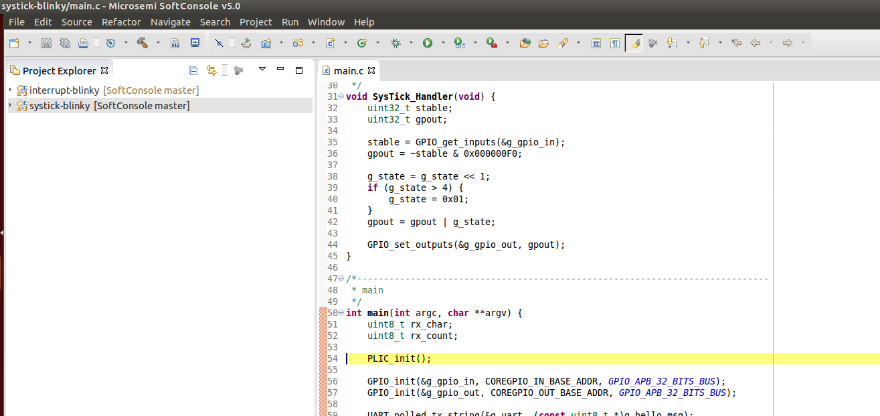

Select the sys-tick example from the Project Explorer
Then build the project by selecting Project – Build Project. Alternatively you can by press Ctrl + b or the hammer marked by the red circle below
Then select debug configurations by selecting Run – Debug Configurations.
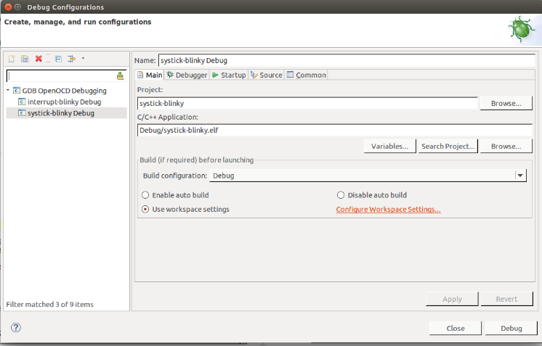
Select systick-blinky. Check if you screen looks similar to this one. If the C\C++ application is missing then, check that you have built the project or add it manually by selecting Search Project and clicking the binary systick-blinky.elf.

Next, select the Debugger tab. Check that the OpenOCD options are as seen below.
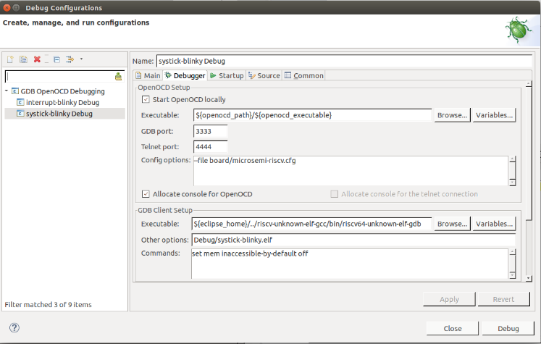
Note: the configuration options are liable to change with different releases of Softconsole v5.x. For Version v5.0 they are --file board/Microsemi-riscv.cfg. For other versions please see the release notes.
Next select Apply, then Debug. Alternatively you can press the bug icon marked in red below to debug the program.
Select the green/yellow play button to run the code straight through.
The LEDs on the M2S090 board should be flashing. If they aren’t power down the board and check that all the connections were made correctly.
Select the red stop button to stop the debug session.
Select the yellow pause button to pause the debug session.

Stop the debug session and reset the board using the white reset button or the power switch.
Start another debug session. This time step through the design using the step over, step into and step return buttons.
Using the step over steps through the code line by line. Use the step into button if you want to see what is happening inside a function. Use the step return button if you are finished looking in a function. When using the step return button within a function, the function will complete the execution and return to where it was called from.

With this walkthrough complete you should be able to do a basic debug using SoftConsole Version 5.0.

